# Visualize the RSI

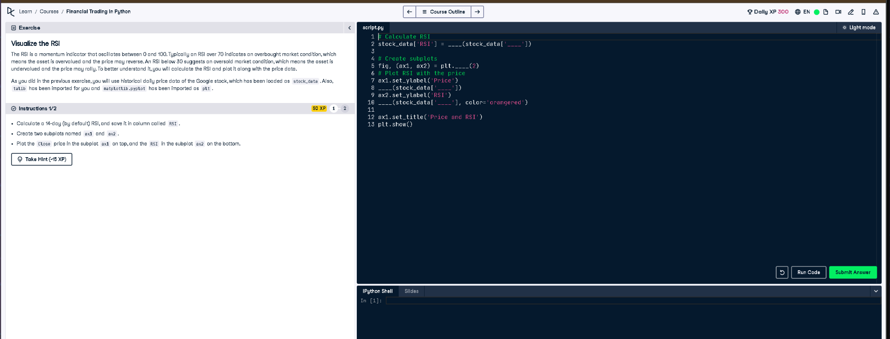

## Full Python Code

# Calculate RSI  
stock_data['RSI'] = talib.RSI(stock_data['Close'])  
  
# Create subplots  
fig, (ax1, ax2) = plt.subplots(2)  
  
# Plot RSI with the price  
ax1.set_ylabel('Price')  
ax1.plot(stock_data['Close'])  
  
ax2.set_ylabel('RSI')  
ax2.plot(stock_data['RSI'], color='orangered')  
  
ax1.set_title('Price and RSI')  
plt.show()

## Simple Explanation (50 Words)

This code calculates the 14-day RSI using talib from the stock’s closing prices. It then creates two subplots: one showing the price and another showing the RSI. RSI values help identify when a stock may be overbought or oversold, giving traders insight into possible trend reversals.